Week 13: POINTERS
General Instructions:
1. Remove existing directories and create a fresh directory of your own. Write all the programs inside the newly created directory.
2. Remove the directory that you created at the end of your Lab session.
3. Inform one of the TAs before you leave the Lab.
-------------------------------------------------------------------------------------------------------------------------------------

Pointers in C are variables that hold memory addresses. They're widely used because they offer a means to express computations efficiently and in a more compact manner. Pointers can store addresses of variables, functions, or even other pointers, enabling low-level memory access, dynamic memory allocation, and various other functionalities. In essence, a pointer is a variable capable of storing the reference to another variable, regardless of its type, whether it's a basic data type like int or float, an array (of one or more dimensions), a struct, a union, or even another pointer.
When a pointer is used, it refers to a specific location in memory. Dereferencing the pointer means accessing the value stored at that memory location. One significant use of pointers is in passing parameters by reference. This allows modifications made to a parameter within a function to be visible outside the function, which is handy for returning multiple values from a function.
📌 As the pointers the memory addresses, their size is independent of the type of data they are pointing to. This size of pointers only depends on the system architecture.

It is important to understand the purpose of two operators in the context of the pointer mechanism.
- The & operator: Address of operator
- The * operator: Dereference operator

Syntax of Pointers
The syntax of pointers is similar to the variable declaration, but we use the ( * ) dereferencing operator in the pointer declaration.
datatype * ptr;

where
- ptr is the name of the pointer.
- datatype is the type of data it is pointing to.
The above syntax is used to define a pointer to a variable. We can also define pointers to functions, structures, etc.
For example,
int *x;
In this case, the variable x is meant to store the address of another int variable.
float *y;
The y variable is a pointer that stores the memory location of a float variable.

How to Use Pointers?
To effectively utilize pointers in C, the process can be broken down into three key steps:

- Pointer Declaration:
Pointer declaration involves defining the pointer without initializing it. This is done by using the (*) dereference operator before the pointer's name. For instance:
int *ptr;
Here, the pointer 'ptr' is declared but not initialized, thus pointing to some random memory address, leading to what are known as wild pointers.
- Pointer Initialization:
Pointer initialization entails assigning an initial value to the pointer variable. Typically, the address of a variable is obtained using the (&) address-of operator and stored in the pointer variable. This process can be done separately or combined with declaration, known as pointer definition. For example:
int var = 10;
int *ptr;
ptr = &var;

Or combined declaration and initialization:
int *ptr = &var;
It's crucial to initialize pointers before usage to avoid potential errors.

- Pointer Dereferencing:
Dereferencing a pointer involves accessing the value stored at the memory address pointed to by the pointer. This is achieved using the (*) dereferencing operator, similar to its usage in pointer declaration. For instance:
int value = *ptr;
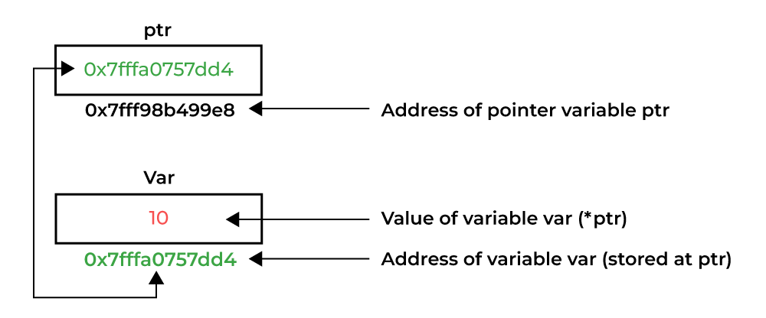
Dereferencing a Pointer in C
C Pointer Example
// C program to illustrate Pointers
#include <stdio.h>

int main()
{
int var = 10;
// declare pointer variable
int* ptr;
// note that data type of ptr and var must be same
ptr = &var;
// assign the address of a variable to a pointer
printf("Value at ptr = %p \n", ptr);
printf("Value at var = %d \n", var);
printf("Value at *ptr = %d \n", *ptr);
return 0;
}
Output
Value at ptr = 0x7fff1038675c
Value at var = 10
Value at *ptr = 10
Now, take an example of a float variable and find its address
#include <stdio.h>
int main(){
float var1 = 10.55;
printf("var1: %f address of var1: %d", var1, &var1);
}

Output
var1: 10.550000 address of var1: 6422044

We can see that the address of this variable (any type of variable for that matter) is an integer. So, if we try to store it in a pointer variable of int type, see what happens −
float var1 = 10.55;
int *intptr = &var1;

The compiler doesn’t accept this, and reports the following error −
initialization of 'int *' from incompatible pointer type
'float *' [-Wincompatible-pointer-types]

It indicates that the type of variable and the type of its pointer must be the same. In C, variables have specific data types that define their size and how they store values. Declaring a pointer with a matching type (e.g., float *) enforces type compatibility between the pointer and the data it points to.
Different data types occupy different amounts of memory in C. For example, an int typically takes 4 bytes, while a float might take 4 or 8 bytes depending on the system.
Adding or subtracting integers from pointers moves them in memory based on the size of the data they point to.
Hence, we declare the floatptr variable of float * type.

Example
#include <stdio.h>
int main(){
float var1 = 10.55;
float *floatptr = &var1;
printf("var1: %f address of var1: %d floatptr: %d address of floatptr: %d", var1, &var1, floatptr, &floatptr );
}

Output
var1: 10.550000 address of var1: 6422044 floatptr: 6422044 address of floatptr: 6422032

Pointer to Pointer
We may have a pointer variable that stores the address of another pointer itself.
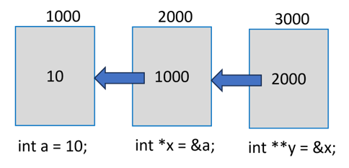
In the above figure, a is a normal int variable, whose pointer is x. In turn, the variable stores the address of x. Note that y is declared as int **, to indicate that it is a pointer to another pointer variable. Obviously, y will return the address of x and *y is the value in x (which is the address of a). To obtain value of a from y, we need to use **y expression. Usually, y will be called as pointer to a pointer.

Example
#include <stdio.h>
int main(){
int var = 10;
int *intptr = &var;
int **ptrptr = &intptr;
printf("var: %d address of var: %d\n",var, &var);
printf("inttptr: %d address of inttptr: %d\n", intptr, &intptr );
printf("var: %d value at intptr: %d\n", var, *intptr);
printf("ptrptr: %d address of ptrtptr: %d\n", ptrptr, &ptrptr );
printf("intptr: %d value at ptrptr: %d\n", intptr, *ptrptr);
printf("var: %d *intptr: %d **ptrptr: %d\n", var, *intptr,
**ptrptr);
return 0;
}

Output
var: 10 address of var: 6422044
inttptr: 6422044 address of inttptr: 6422032
var: 10 value at intptr: 10
ptrptr: 6422032 address of ptrtptr: 6422024
intptr: 6422044 value at ptrptr: 6422044
var: 10 *intptr: 10 **ptrptr: 10
You can have a pointer to an array as well as a derived type defined with struct. Pointers have important applications. Thet are used while calling a function by passing the reference. They also help in overcoming the limitation of a function’s ability to return only a single value. With pointers, you can obtain the effect of returning multiple values or arrays.

Pointer to array
int arr[10];
int *p[10]=&arr; // Variable p of type pointer is pointing to the address of an integer array arr.

Pointer to a function
void show (int);
void(*p)(int) = &display; // Pointer p is pointing to the address of a function

Pointer to structure
struct st {
int i;
float f;
}ref;
struct st *p = &ref;

Pointer arithmetic

Increment/decrement operators
We know that the symbols ++ and -- are defined as increment and decrement operators in C. They are unary operators, used in prefix or postfix manner with numeric variable operands, and increment or decrement the value of the variable by one.
Assume that an integer variable x is created at address 1000 in the memory, with 10 as its value. The x++ statement makes x as 11.

int x = 10; //created at address 1000

x++; // x becomes 11
What happens if we declare y as pointer to x and increment y by 1 (with y++)? Assume that the address of y itself is 2000.

int x = 10; //created at address 1000

int *y = &x ; // y is created at address 2000 and holds 1000 – address of x

y++; //y becomes 1004
Since the variable y stores 1000 (the address of x), we expect it to become 1001 because of ++ operator, but increment by 4, which is the size of int variable.
The reason behind this is, if address of x 1000, it occupies 4 bytes 1000, 1001, 1002 and 1003. Hence, the next integer can be put only in 1004 and not before it. Hence y the pointer to x becomes 1004 when incremented.

Example
Let us see the realistic example −

#include <stdio.h>

int main(){

int x = 10;

int *y = &x;

printf("value of y before increment: %d\n", y);

y++;

printf("value of y after increment: %d", y);

}

Output

value of y before increment: 6422036

value of y after increment: 6422040
You can see that the value has increased by 4.
Similarly, the -- operator decrements the value by the size of the data type. Let us change the types of x and y to double and float * and see the effect of decrement operator.

Example

#include <stdio.h>

int main(){

double x = 10;

double *y = &x;

printf("value of y before decrement: %ld\n", y);

y--;

printf("value of y after decrement: %ld", y);

}

Output

value of y before decrement: 6422032

value of y after decrement: 6422024
When an array is declared, the elements are stored in adjacent memory locations. In case of int array, each array subscript is placed apart by 4 bytes, as the following figure shows −
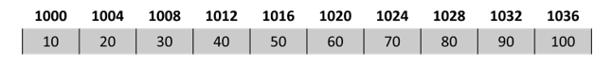
Hence, if a variable stores the address of 0th element of the array, increment takes it to the 1st element. Likewise, we can traverse the array by incrementing the pointer successively.

Example

#include <stdio.h>

int main(){

int a[]= {10, 20, 30, 40, 50, 60, 70, 80, 90, 100};

int len = sizeof(a)/sizeof(int);

int *x = a;

int i = 0;

for (i=0; i<len; i++){

printf("Address of subscript %d = %d Value = %d\n", i, x, *x);

x++;

}

return 0;

}

Output
Address of subscript 0 = 6421984 Value = 10
Address of subscript 1 = 6421988 Value = 20
Address of subscript 2 = 6421992 Value = 30
Address of subscript 3 = 6421996 Value = 40
Address of subscript 4 = 6422000 Value = 50
Address of subscript 5 = 6422004 Value = 60
Address of subscript 6 = 6422008 Value = 70
Address of subscript 7 = 6422012 Value = 80
Address of subscript 8 = 6422016 Value = 90
Address of subscript 9 = 6422020 Value = 100

Addition/subtraction of pointers
We are familiar with + and − operators when used with normal numeric operands. When used with pointers, their behaviour is a little different.
Since the pointers are fairly large integers (especially in modern 64 bit systems), addition of two pointers is meaningless. When we add a 1 to a pointer, it points to next location where an integer may be stored. Obviously, when we add a pointer (itself a large integer), the location it points, may not be in the memory layout.
However, subtraction of two pointers is realistic. It returns the number of data types that can fit in the two pointers.
Let us the array in the previous example, and perform the subtraction of pointers of a[0] and a[9]

Example

#include <stdio.h>

int main(){

int a[]= {10, 20, 30, 40, 50, 60, 70, 80, 90, 100};

int *x = &a[0]; //zeroth element

int *y = &a[9]; //last element

printf("Add of a[0]: %ld add of a[9]: %ld\n", x, y);

printf("subtraction of two pointers: %ld", y-x);

}

Output

Add of a[0]: 140729162482768 add of a[9]: 140729162482804

subtraction of two pointers: 9
It can be seen that the numerical difference between the two integers is 36, it tells that the subtraction is 9, because it can accommodate 9 integers between the two pointers.

Pointer Comparisons
Pointers may be compared by using relational operators, such as ==, <, and >. If p1 and p2 point to variables that are related to each other, such as elements of the same array, then p1 and p2 can be meaningfully compared.
The following program modifies the previous example − one by incrementing the variable pointer so long as the address to which it points is either less than or equal to the address of the last element of the array, which is &var[MAX − 1]

Example

#include <stdio.h>

const int MAX = 3;

int main () {

int var[] = {10, 100, 200};

int i, *ptr;

/* let us have address of the first element in pointer */

ptr = var;

i = 0;

while ( ptr <= &var[MAX - 1] ) {

printf("Address of var[%d] = %d\n", i, ptr );

printf("Value of var[%d] = %d\n", i, *ptr );

/* point to the previous location */

ptr++;

i++;

}

return 0;

}

Output
Address of var[0] = 6422020
Value of var[0] = 10
Address of var[1] = 6422024
Value of var[1] = 100
Address of var[2] = 6422028
Value of var[2] = 200

Usage of pointer

There are many applications of pointers in c language.
1) Dynamic memory allocation
Dynamic memory allocation allows programs to allocate memory at runtime, offering flexibility in managing memory resources. Pointers play a crucial role in dynamic memory allocation, enabling efficient memory usage and deallocation. Two commonly used functions for dynamic memory allocation in C are malloc() and calloc().
- malloc(): Allocates a block of memory of specified size.
- calloc(): Allocates multiple blocks of memory, initializing each byte to zero.
Example: Dynamic Memory Allocation
#include <stdio.h>
#include <stdlib.h>

int main() {
int *ptr;
int n = 5;

// Using malloc to allocate memory for an array of 5 integers
ptr = (int *)malloc(n * sizeof(int));

if (ptr == NULL) {
printf("Memory allocation failed\n");
return 1;
}

// Printing uninitialized array elements
printf("Using malloc():\n");
for (int i = 0; i < n; i++) {
printf("ptr[%d] = %d\n", i, ptr[i]); // Elements may contain garbage values
}

free(ptr); // Freeing the allocated memory

// Using calloc to allocate memory for an array of 5 integers
ptr = (int *)calloc(n, sizeof(int));

if (ptr == NULL) {
printf("Memory allocation failed\n");
return 1;
}

// Printing initialized array elements
printf("\nUsing calloc():\n");
for (int i = 0; i < n; i++) {
printf("ptr[%d] = %d\n", i, ptr[i]); // Elements are initialized to zero
}

free(ptr); // Freeing the allocated memory

return 0;
}
Output:

Using malloc():
ptr[0] = 12603328
ptr[1] = 12603392
ptr[2] = 12603456
ptr[3] = 12603520
ptr[4] = 12603584

Using calloc():
ptr[0] = 0
ptr[1] = 0
ptr[2] = 0
ptr[3] = 0
ptr[4] = 0

In this example, both malloc() and calloc() are used to allocate memory for an array of 5 integers. However, the key difference is that malloc() allocates uninitialized memory, while calloc() allocates memory and initializes all its bytes to zero.

When printing the array elements allocated with malloc(), you may observe garbage values because the memory is uninitialized. Conversely, the array elements allocated with calloc() will contain zeros, ensuring predictable initial values. This distinction highlights a practical difference between malloc() and calloc() in certain scenarios.

2) Arrays, Functions, and Structures
Pointers are extensively used in arrays, functions, and structures, offering advantages in code efficiency and flexibility. When dealing with arrays, pointers enable efficient traversal and manipulation of array elements. In functions, pointers facilitate passing parameters by reference, allowing modifications to be reflected outside the function. Similarly, in structures, pointers enable dynamic memory allocation and manipulation of complex data structures.
Example (array): This code demonstrates the use of pointers to manipulate arrays.
#include <stdio.h>

int main() {
int arr[5] = {1, 2, 3, 4, 5};
int *ptr = arr; // Pointer pointing to the first element of the array

printf("Array elements: ");
for (int i = 0; i < 5; i++) {
printf("%d ", *(ptr + i)); // Accessing array elements using pointers
}
printf("\n");

return 0;
}
Output:
Array elements: 1 2 3 4 5

Example (Function): This code demonstrates passing parameters by reference to a function, where the function swaps the values of two integers.
#include <stdio.h>

// Function prototype
void swap(int *x, int *y);

int main() {
int a = 10, b = 20;

printf("Before swapping - a: %d, b: %d\n", a, b);
swap(&a, &b); // Pass addresses of a and b
printf("After swapping - a: %d, b: %d\n", a, b);

return 0;
}

// Function definition: Swap two integers
void swap(int *x, int *y) {
int temp = *x;
*x = *y;
*y = temp;
}
Output:
Before swapping - a: 10, b: 20
After swapping - a: 20, b: 10
Example (Structure): This code demonstrates dynamic memory allocation and manipulation of a structure using pointers.
#include <stdio.h>
#include <stdlib.h>
#include <string.h>

// Structure definition
struct Student {
char name[20];
int age;
};

int main() {
// Dynamic memory allocation for a structure
struct Student *ptr;
ptr = (struct Student *)malloc(sizeof(struct Student));
if (ptr == NULL) {
printf("Memory allocation failed.");
exit(1);
}

// Accessing structure members using pointers
strcpy(ptr->name, "John");
ptr->age = 20;
printf("Student details - Name: %s, Age: %d\n", ptr->name, ptr->age);

free(ptr); // Freeing allocated memory

return 0;
}
Output:
Student details - Name: John, Age: 20
Links to explore more.
https://www.tutorialspoint.com/cprogramming/c_passing_pointers_to_functions.htm
https://www.geeksforgeeks.org/c-language-2-gq/pointers-gq/
https://www.geeksforgeeks.org/c-language-2-gq/advanced-pointer-c-gq/
https://codeforwin.org/c-programming/pointer-programming-exercises-and-solutions-in-c

